SitePal on Power Point without Plugins
- Copy the Flash Embed Code from SitePal.
- Click on Options, and then Customize Ribbon. Place a check next to Developer in the main tabs box, and then return to normal view. You will now have a DEVELOPER tab on the ribbon.
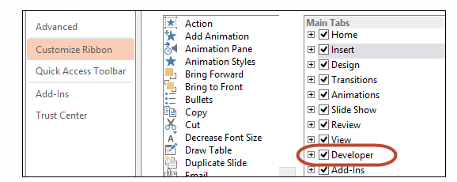
- On the Developer tab click the More Controls command in the Controls group.
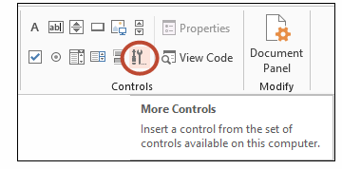
- Scroll down the More Controls dialog box and select Shockwave Flash Object, then click OK.
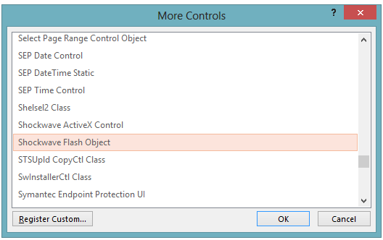

- Once you click OK in the dialog box illustrated above, your cursor will turn to a cross-hair. Hold down the mouse button and draw a rectangle. When you release the mouse button the rectangle will appear with an X in it.

- Right click the X in the rectangle you have drawn for the Shockwave Flash Object. Select Property Sheet from the context menu.
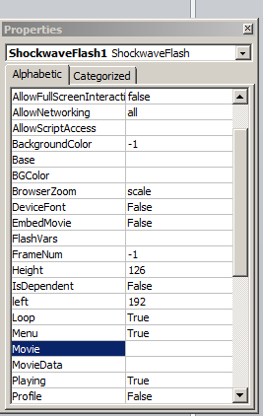
- In the resulting Properties dialog, click in the blank field next to Movie, and paste in the URL/Embed Code from the SitePal. It will look something like this:
http://content.oddcast.com/vhss/full-body-player.swf?acc=3567323&ss=2396118&sl=0&bgcolor=0x&embedid=2db853fc06bf6782fb2c2860bcb19f09

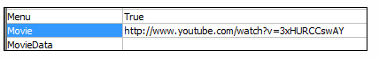
- Then close the Properties box. That’s it.
- Click F5 to play the scene.

